**LIFE CYCLE HOOKS**

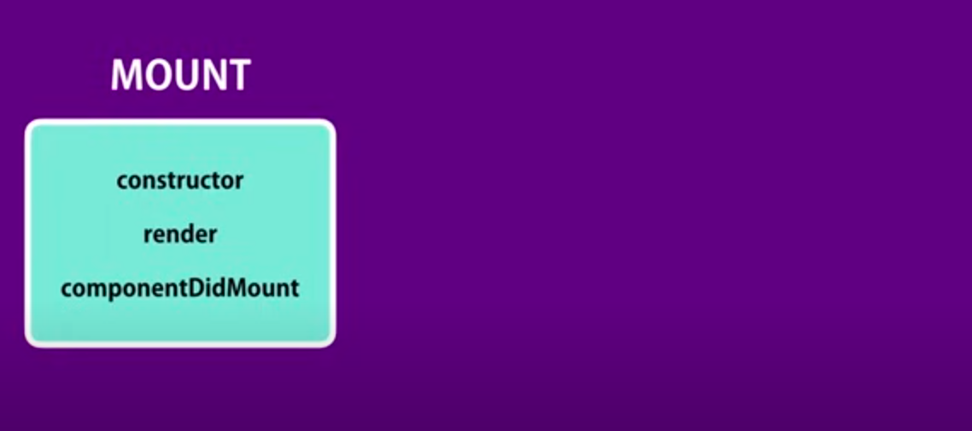

**Mount**: instance of a component is created and inserted into the DOM.

1. Constructor:

* Only called once
* Right place to initialize the props in this class for this state
* Cannot use set state
* For using props first need to pass it as param to both constructor & super

1. Render:

* All functionality to be displayed
* Return a function

1. componentDidMount:

* Called after component is rendered in DOM.
* Perfect place for ajax call to get data from server and call setState to new data

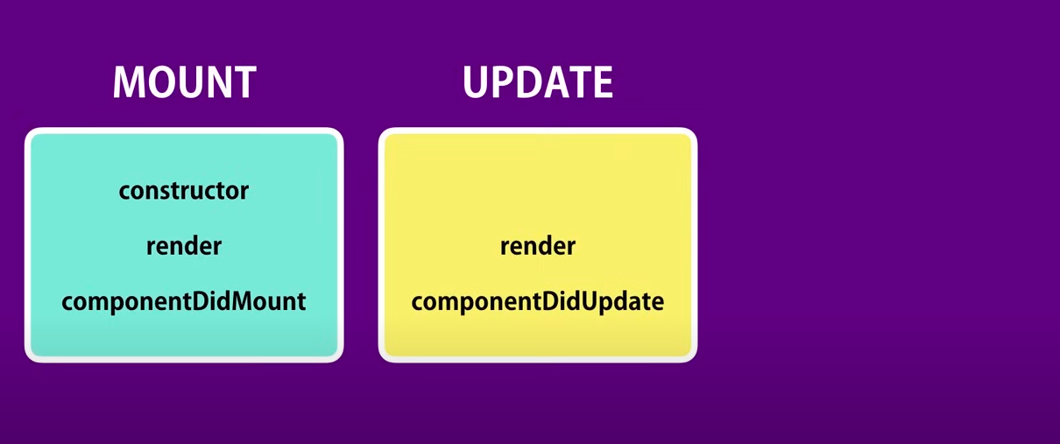

**Update**: state or props of the component get changed

1. Render:

* All component tree is rerender on a change

1. componentDidUpdate:

* Can get previous props and state and use it to compare to new virtual dom and make ajax call or do any functionality required

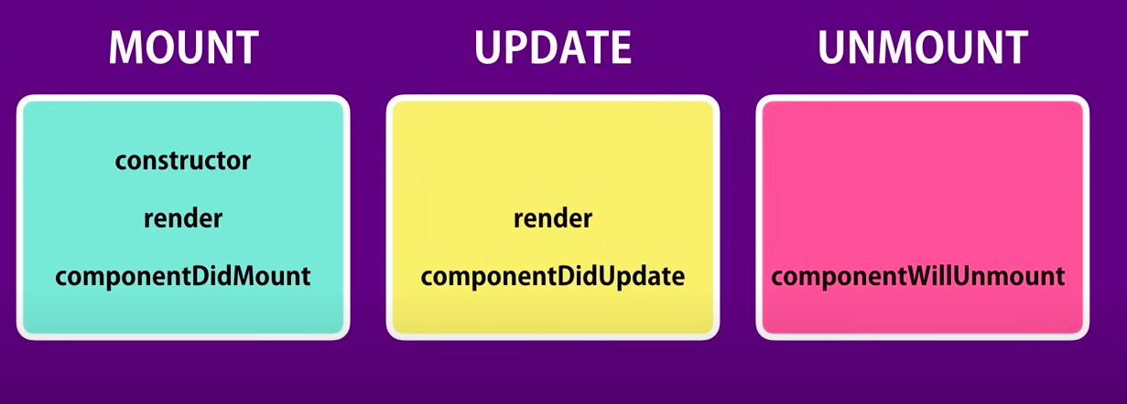

**Unmount**: component is removed from the DOM. Example: counter removed from list

1. componentWillUnmount:

* Can be use for any type of cleanup required before component removed from DOM